Nigeria

## Political Stability Estimate Data

The data set shows the political stability estimate of the country each year.

## # A tibble: 19 x 5  
## country iso3c date stability stabilityCategory4   
## <chr> <chr> <dbl> <dbl> <chr>   
## 1 Nigeria NGA 1996 -1.06 highly unstable   
## 2 Nigeria NGA 1998 -0.586 moderately unstable  
## 3 Nigeria NGA 2000 -1.46 highly unstable   
## 4 Nigeria NGA 2002 -1.63 highly unstable   
## 5 Nigeria NGA 2003 -1.63 highly unstable   
## 6 Nigeria NGA 2004 -1.75 highly unstable   
## 7 Nigeria NGA 2005 -1.67 highly unstable   
## 8 Nigeria NGA 2006 -2.03 highly unstable   
## 9 Nigeria NGA 2007 -2.01 highly unstable   
## 10 Nigeria NGA 2008 -1.86 highly unstable   
## 11 Nigeria NGA 2009 -2.00 highly unstable   
## 12 Nigeria NGA 2010 -2.21 highly unstable   
## 13 Nigeria NGA 2011 -1.96 highly unstable   
## 14 Nigeria NGA 2012 -2.04 highly unstable   
## 15 Nigeria NGA 2013 -2.09 highly unstable   
## 16 Nigeria NGA 2014 -2.13 highly unstable   
## 17 Nigeria NGA 2015 -1.93 highly unstable   
## 18 Nigeria NGA 2016 -1.88 highly unstable   
## 19 Nigeria NGA 2017 -1.94 highly unstable

## Political Stability Estimate Plot

The plot shows the trends of stabilization and destabilization for the each country.

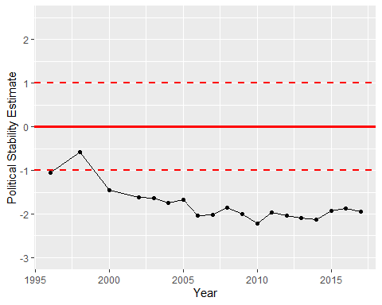

Political Stability Trend